**Hard Geo?**

**Input:** Standard Input, **Output:** Standard Output

**Time Limit:** 1 second(s)

**Memory Limit:** 256 megabytes

**Problem Statement:**

See the picture carefully. **XYNM** is a **trapezium** and A **circle inside touches all of its four sides**.

Assume that,

1. **(XM || YN) means XM = a and YN = b are parallel.**

2. **(XY _|_ YN) means XY is perpendicular to YN.**

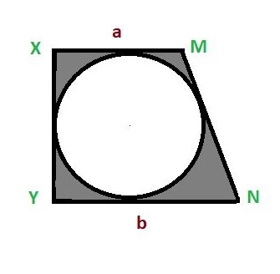

https://i.imgur.com/l1ab8JX.jpg

Given **a** and **b**, which are the length of **two parallel sides of the trapezium**. You have to find **the area of the shaded regions**.

**Note: Use pi value as, PI = 2 * acos(0.0)**

**Input:**

The first line contains one integer **T (1 ≤ T ≤ 105)** — the number of test cases.

Each test case consists of two integers **a** and **b** where **(1 <= a ,b <= 103)**

**Output:**

For each test case, print the **area** in a single line. Error less than **1e-6** will be ignored.

**Sample Input/Output:**

|  |  |
| --- | --- |
| **Sample Input** | **Sample Output** |
| 2  4 7  2 3 | 7.644557  1.476107 |